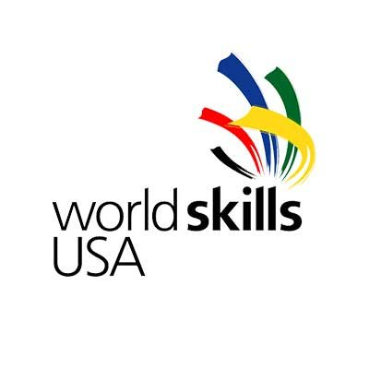
FOR IMMEDIATE RELEASE:

SkillsUSA Contacts:
Jane DeShong Short or Karen Kitzel
Phone: (703) 777-8810
Emails: jshort@skillsusa.org or kitzel@skillsusa.org

Young Skilled Aircraft Maintenance Technician
to Compete at WorldSkills Competition

Leesburg, Va. — Alex Millikan, of Trinity, N.C., will represent the United States in Aircraft Maintenance at the biennial WorldSkills Competition in Kazan, Russia. Millikan will compete as a member of the WorldSkills USA team, selected and trained by SkillsUSA. The 45th international event will be held Aug. 22-27, 2019.

Millikan was interested in automobiles for as long as he can remember, but he didn’t become interested in aircraft maintenance until his junior year of high school. When he signed up for the U.S. Air Force Reserves, he discovered his passion.

Aircraft maintenance runs in Millikan’s family. His father is an aircraft pilot, and his grandfather was an avionics technician in the U.S. Air Force.

Experience in the Air Force Reserves, his education from Guilford Technical Community College (N.C.), his training at Timco Aviation Services and at the General Electric Durham Engine Facility have all contributed to Millikan’s aircraft maintenance skills. “I love troubleshooting and having the ability to fix problems with aircraft. My love of fixing things and solving problems motivates me to be a better mechanic every day,” he said.

While he is preparing for the WorldSkills competition, Millikan is juggling a full-time job, school and his commitment to the Air Force Reserves. He is also planning to get his private pilot’s license and a bachelor’s degrees in aviation safety or aviation maintenance. “Times ahead will be rigorous, but the reward will be worth it,” he continued. “It is an honor to represent the United States and have the ability to put my skills to the test with other nations around the globe. Having this opportunity to represent the United States on a global stage is not only an honor, but also a privilege. And, to be able to do something I love just makes it that much more enjoyable.” To see a video of Millikan, go to: https://youtu.be/hYY1MJ8NEtE

Every two years, WorldSkills hosts the world championships of skills, which attracts more than 1,600 competitors from more than 76 countries and regions around the world to compete in more than 50 different trade skills. Considered the best in the world at each trade skill, contestants compete before the public for four days in contests that are run and judged by industry using demanding international standards. They represent the best students from each nation and many are highly trained by their sponsoring country. To see a list of competitions, go to: https://worldskills2019.com/en/event/skills/

There are 22 members on the WorldSkills USA Team, with an average age of 19. Other occupational areas in which the United States plans to compete include Autobody Repair, Automobile Technology, Bakery, Bricklaying, Cabinetmaking, Car Painting, CNC Milling, Cooking, Cyber Security, Graphic Design, Hairdressing, Heavy Vehicle Maintenance, Mechanical Engineering CAD, Mechatronics, Plumbing and Heating, Print Media, Restaurant Service, Web Technologies and Welding.

Hundreds of thousands of spectators, public policymakers, employers, teachers, trainers, technical experts and government officials from around the world will attend this competition. The event will be held at the Kazan Expo International Exhibition Centre. For more information about the competition, go to: https://worldskills2019.com/en

For more information about Alex Millikan and the WorldSkills USA team, go to: www.worldskillsusa.org

Unlike other national teams in the WorldSkills Competition, the WorldSkills USA team is funded solely through private donations. To donate funds or in-kind support, go to: www.worldskillsusa.org/donate/

About SkillsUSA
SkillsUSA is a vital solution to the growing U.S. skills gap. SkillsUSA empowers its members to become world-class workers, leaders and responsible American citizens as it improves the quality of our nation’s future skilled workforce. The nonprofit partnership of students, instructors and industry ensures America has the skilled workforce it needs to stay competitive. SkillsUSA helps every student excel through the development of SkillsUSA Framework skills that include personal, workplace and technical skills grounded in academics. The association serves more than 360,000-member students and instructors per year in middle schools, high schools and colleges. This diverse talent pipeline covers 130 trade, technical and skilled service occupations, the majority STEM-related. More than 600 corporations, trade associations, businesses and labor unions actively support SkillsUSA at the national level. Local, state and national championships are designed and judged by industry to set relevant standards for career and technical education and provide recognition opportunities for students. SkillsUSA programs also help to establish industry standards for job skill training in the lab and classroom and promote community service. SkillsUSA is recognized by the U.S. Department of Education and is cited as a “successful model of employer-driven youth development training program” by the U.S. Department of Labor. SkillsUSA offers technical skill assessments and workplace credentials through the SkillsUSA Career Essentials program, a cutting-edge solution that defines, implements and measures career readiness skills for students. For more information: www.skillsusa.org

About WorldSkills
Since 1950, WorldSkills has come to symbolize the pinnacle of excellence in vocational training. It provides a unique means of exchange and comparison of world-class competency standards in the industrial trades and service sectors of the global economy. The continued growth of WorldSkills International attests to the fact that traditional trade and craft skills, along with newer technology’s multi-skilled occupations, make an essential contribution to the economic and social well-being of people everywhere. For more information, go to: www.WorldSkills.org

# # #

